ZTE U887 3G Smart Mobile Phone Android 2.3 5" TFT TD-SCDMA GSM Support GPS Dual Camera Bluetooth Wi-Fi
Basic Parameters
Brand Model | ZTE U887
Mobile Phone Style | Bar style
Screen Size | 5-inch
Screen Type | TFT, capacitive multi-point touch screen
Resolution | 854x480 pixels
Screen Color | 16 000 000 Color
Screen pixel density | 187ppi
Network Type | Dual Card Dual Mode (GSM,TD-SCDMA)
Data Traffic | GPRS,EDGE,TD-SCDMA
Frequency Band | 2G: GSM 900/1800/1900 MHz
Frequency Band | 3G: TD-SCDMA 2010-2025 MHz
Keyboard Type | Virtual keyboard
Input Mode | Handwritten
Language | Chinese and English
Interface | 3.5 mm earphone ,Micro USB V2.0
Color | White
Size | 147x78.2x9.9mm
Weight | 150g
Hardware
Operating System | Android 2.3
CPU | Single Core 1.2 GHz
GPU | -
RAM | 512MB
ROM | 512MB
Expansion Memory | Support micro SD/TF card up to 32GB
SIM Card Type | SIM
Battery Capacity | 2000mAh
Basic Function
Call record | Support
Address book | Support
Others | Short messages (SMS),multimedia message (MMS),recording function ,flight mode, scene mode, theme mode, alarm clock, calculator, calendar
Features
Sensor | G-sensor, Light Sensor, Proximity Sensor
GPS Navigation | Support built-in GPS for effortless navigation, and also support A-GPS
E-compass | Support
WLAN | Support WIFI,IEEE802.11b/g/n
Bluetooth | Support Bluetooth
Camera
Camera Type | Built-in dual camera,0.3 mega pixels front camera, 5.0 mega pixels back camera
Sensor Type | CMOS
Flash Light | Support
Auto Focus | Support
Image Size | Maximum support 2592×1944 pixel photo shoot
Video recording | Support
Continuous Shooting | Support
Entertainment
Audio Format | Support MP3/WAV/AMR/AWB
Video Format | Support 3GP/MPEG4
Image Format | Support JPEG/BMP/GIF/PNG
E-Book Format | Support TXT/CHM/DOC/HTML
Ringtones Type | Support Polyphonic/MP3
FM Radio | Support
Game | Support
Browser | Support WAP/www
SNS Service | Support, such as Face book, Twitter etc
Others | Android market, Browser, Live wallpapers, Gallery, File Manager,

Black ZTE U887 Android Phone
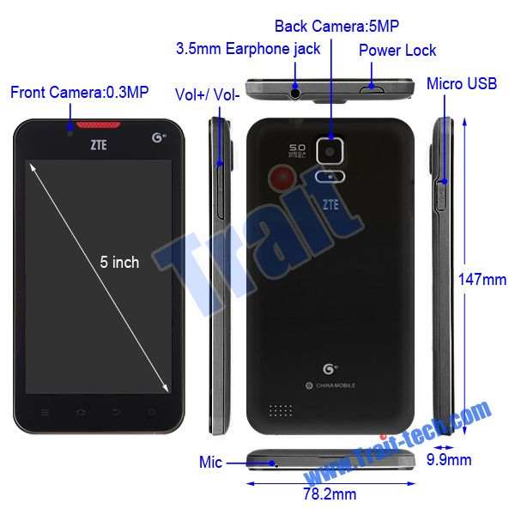

ZTE U887 3G Smart Mobile Phone
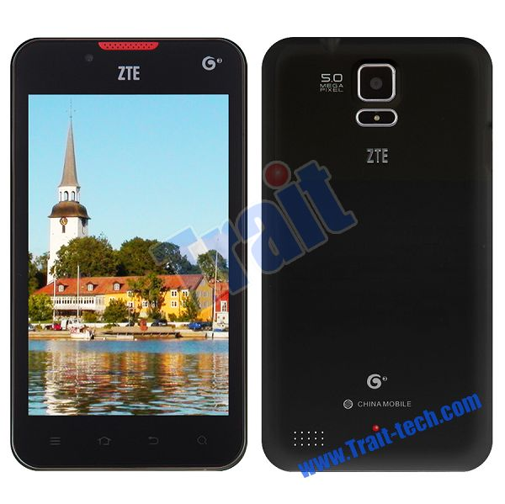

Black ZTE U887 Android Phone

ZTE U887 3G Smart Mobile Phone

5" TFT TD-SCDMA GSM ZTE U887 Android Phone

