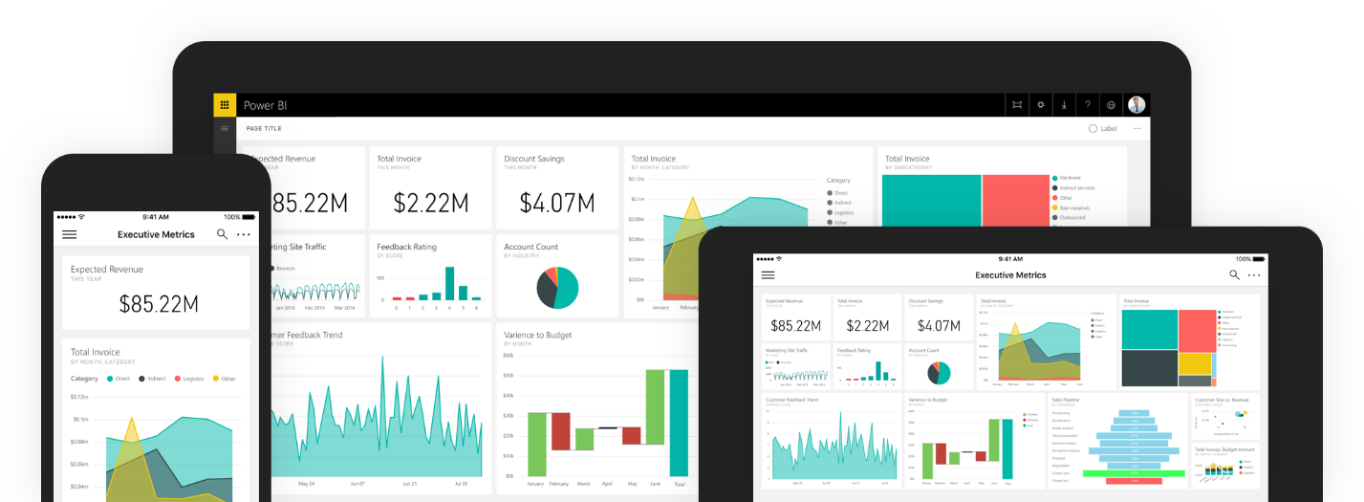4 - Days Training Course in Advanced Microsoft Excel: Dar es Salaam
TRAINING COURSE IN BIG DATA ANALYTICS USING EXCEL
TRAINING OVERVIEW
In this Big Data Analytics with Excel training course, you will learn how to manage and analyze multi-millions records of data with Excel.
You will start by learning advanced formatting techniques including data validation and conditional formatting. Then data cleansing, including removing duplicate records, replacing text, and merging and splitting data columns. From there, you will be taught about Excel tables, pivot tables, charts, and pivot charts. The trainer will then cover Excel built in Power Business Intelligence (Power BI) solutions including Power Query, Power Pivot, Power View and Power Map. Finally, you will learn how to automate some repetitive tasks by recording macros.
After completing this training course, you will have learned everything you need to know to effectively manage and analyze large quantities of data with Excel. Exercise files will be provided during training allowing you to follow along with the trainer throughout the lessons.
COURSE OUTLINE
Day 1: Advanced Data Cleaning and Formatting Techniques
(In this day, you'll learn how to perform advanced formatting using Excel)
- Data validation in excel - Preventing unwanted data and ensuring data quality
- Creating drop down lists
- Creating dependent/multi-tiered drop down list
- Built-in conditional formatting
- Conditional formatting using logical formulas
- Data cleansing skills - Removing duplicates, splitting columns etc.

Day 2: Advanced Formulas and Functions
(In this day, you'll learn how to utilize some of advanced functions available in Excel. This is a skeleton outline. More functions not listed here will be taught)
- Day 1 recap
- Logical functions - IF, OR, AND, IFERROR, SWITCH etc.
- Text functions - LEN, LEFT, RIGHT, UPPER, LOWER, TRIM, CLEAN, CONCATENATE, PROPER, MID, FIND/SEARCH, REPLACE/SUBSTITUTE, REPT, TEXT etc.
- Mathematical & statistical functions - COUNT, COUNTIF(S), AVERAGE, AVERAGEIF(S), SUM, SUMIF(S), MAX, MIN, LARGE, SMALL, MEAN, MEDIAN, MODE etc.
- Lookup functions - INDEX, MATCH, HLOOKUP, VLOOKUP, CHOOSE, OFFSET etc.

Day 3: Excel Built-in Power Business Intelligence Solutions
(In this day, you'll learn how to utilize advanced business intelligence tools that have been added in Excel starting version 2010 namely Power Query, Power Pivot, Power View and Power Map for analysis of BIG DATA)
- Day 2 recap
- Import data into Excel from almost any source using Power Query. You'll learn how to Import data from all modern Relational Database Management Systems such as MS Access, SQL Server, MySQL, Oracle, PostgreSQL and many other sources
- Import data from online sources such as World bank, Wikipedia, Facebook directly into Excel
- Import and analyze data from multiple sources such as multiple Excel workbooks using Power Query
- This is a fantastic time saver that eliminates a burden of copy and paste from multiple workbooks into a single workbook
Import multi-millions of data (more than 1048576 a normal excel can handle) and create data models using Power Pivot. Power Pivot can handle even 100M records/rows of data without a problem
- Create Pivot Tables and Pivot Charts using huge data imported into Power Pivot

Day 4: Creating Dynamic Dashboards for Visualization and Reporting
(In this final day, you'll learn how to connect skills covered since day 1 to create a dynamic reporting dashboard for your company or organization. We will also cover the basics of macro recording for automating repetitive tasks and introduce you to Power BI Desktop, a free, data visualization and tool from Microsoft)
- Day 3 recap
- Create Dynamic Dashboards using Excel - You'll learn how to create dynamic dashboard using a combination of Pivot tables and Charts connected to slicers and timelines
- Power View and Power Map - You'll learn how to improve your dashboard by adding powerful charts such as Drill-down charts and maps using recently added advanced tools, Power View and Power Map
Recording, saving, editing and running macros to automate boring recurring tasks
- Introduction to Power BI Desktop
- Course wrap-up, and presenting certificate of attendance to participants

COURSE FEE:
- TZS 350,000 covering training, lunch and two tea breaks

VENUE:
- TBD

TRAINING DATES:
- 2nd May 2017 - 5th May 2017 (4 Days)

PAYMENT METHOD:
Pay for this course through NMB Bank Account details below and send your payment alert by email through: info@techtraintz.com
- Account Name: TECHTRAIN ACADEMY
- Account Number: 22410019565
- Branch: NMB Mbagala
Call +255 629 610 039 for more information

