CCTV Surveillance Cameras
Protect your home and business with high-resolution surveillance cameras from Green Vision Company ltd (security contractors) and play back events at will. You can also view your cameras using cell phone, tablet or PC. Benefits of CCTV:
- Prevent theft and illicit activities.
- Protect employees.
- Maintain records and back up of events.
- Aid local authorities.
- Receive email alerts when motion detected after office hours
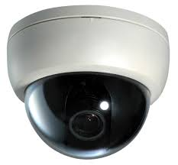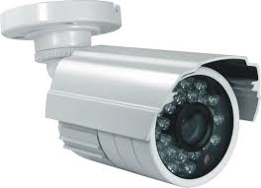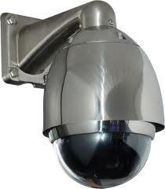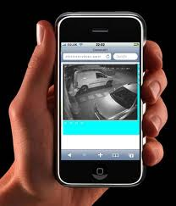
Dome Bullet PTZ Remote Viewing
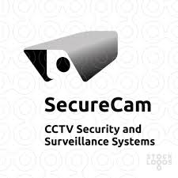
Authorized Parteners 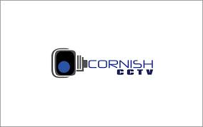

Access Control
Say goodbye to keys and hello to keyless entry.
Access control systems are effective systems when it comes to controlling access in the office environment. Benefits of access control:
- Restrict unauthorized access.
- Track entry/exit of personnel.
- Allow restricted access to the work place after office hours.
- Eliminate problems with keys-duplications, jams, etc.
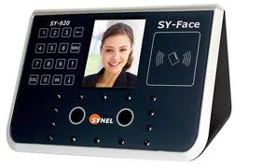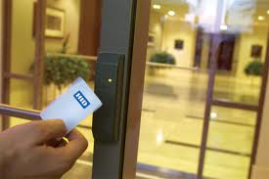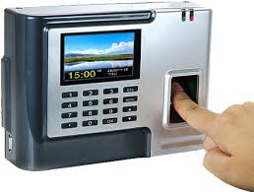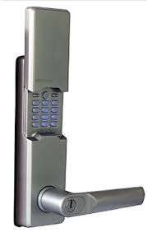
Facil Recognition Access Card Finger Print Pincode
Authorized Partners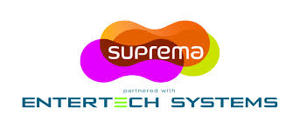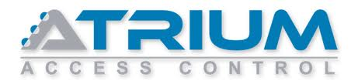
Automatic Gates and Barriers.
Improved security at your residence/business by automating your gate. As sole authorized dealers of Nice Hansa, we can convert any gate into an automated one. Benefits of Gate Automation:
Open/Close gate from the comfort of your own home/vehicle.
- Reduce gate opening times.
- Solar panel and battery backup ensures that your gates are always operating
- Integrate with intercoms, beams and other access control devices.
- Provides security for children and pets.
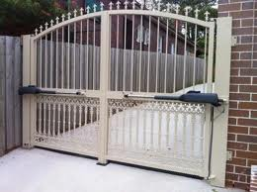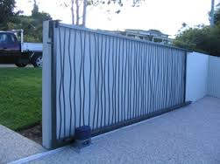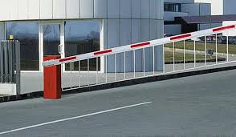
Swing Gate Sliding Gate Barriers

Authorized Partners 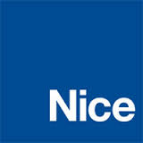

Intruder Detection Systems
Intruder alarm Systems are the most common form of security. Green Vision company ltd are authorized partners for MAMI alarm systems can be integrated with various sensors making them the most comprehensive form of security available. Benefits of Alarm Systems:
- Deter possible intrusion by audible and visual alerting options.
- Instant notification to first response team via radio or SMS text message
- Scalable solution allowing for installation of additional sensors when required.

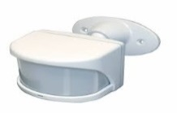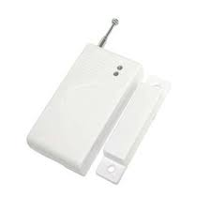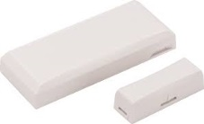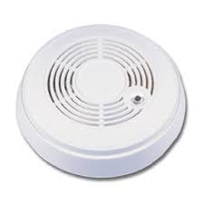
Motion/s Door/s Window/s Smoke/s
Authorized Parteners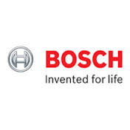 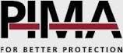

Electric Fence
Electric Fences are now a common effective protection system for most households and businesses. Green vision company ltd are authorized partners of HAMMER brand.
- Effective physical and psychological barrier against intruders.
- Integrate with existing alarm systems.
- Durable and easy to maintain.
- Add sensor switches to automatically adjust sensitivity.
- Zoning provides information on attempted point of entry.
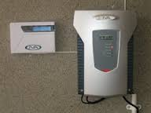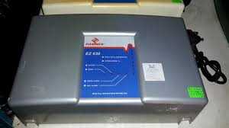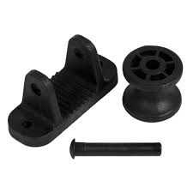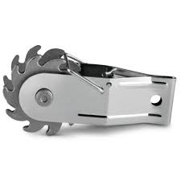
JVA Energizer Hammer Energizer Stainless Roller Insulator Strainer
Authorized Parteners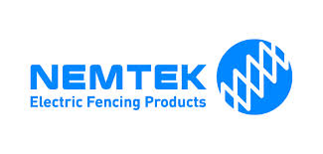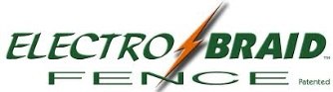

Turnstiles and Bollards
Crowd control is essential when it comes to certain types of businesses. Turnstiles offer an effective solution for employee management and crowd movement especially in supermarket, large factories and the like.
Rising or fixed bollards are the ultimate solution in vehicle barriers. The main benefits of rising bollards are that they operate even in the event of a vehicle knocking into them. Operated automatically bollards can be programmed to allow certain vehicles in at allocated times to ensure effective vehicle control.
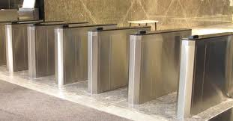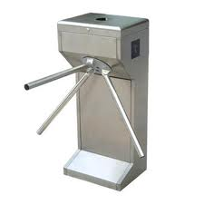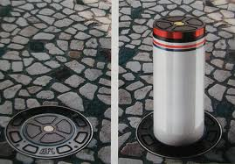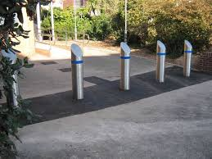
Turnstiles Turnstiles Rising Bollard Fixed Bollard
Authorized Partners 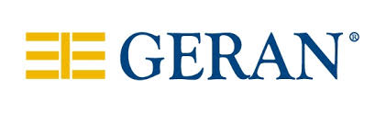 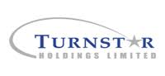

Smoke Cloak
The first in Tanzania, the Smoke Cloak is a revolutionary product for the high-end market. It works on a very simple concept: if you can’t see it, you can’t steal it! The smoke cloak unit blow out dense harmless fog to reduce visibility and in essence sets a cloak over items/personnel that need to be protected from intruders. Along with the smoke cloak, customized light strobes can also be added to ensure the intruders are completely disoriented, which increases the possibility of capture.
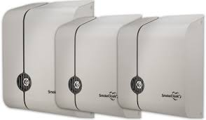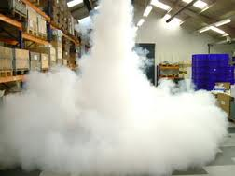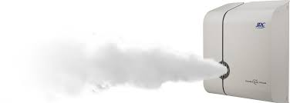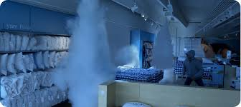

Authorized Partner 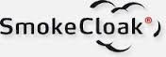

Time and Attendance Systems
A time and attendance system is a way for your organization to save money and eliminate the frustrations of a manual process. Increase efficiency, manage labor costs and maximize profits by implementing and electronic, integrated time and attendance system. Benefits of Time and Attendance Systems.
- Reduce inherent problems with manual system.
- Eradicate shadow employees.
- Increase efficiency and productivity.
- Save money with accurate overtime calculations.
- Increase employee satisfaction.
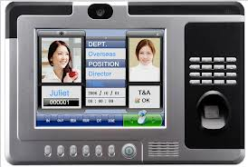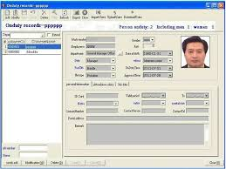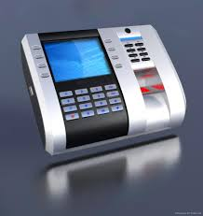

Authorized Parteners. 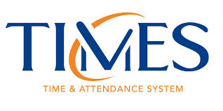

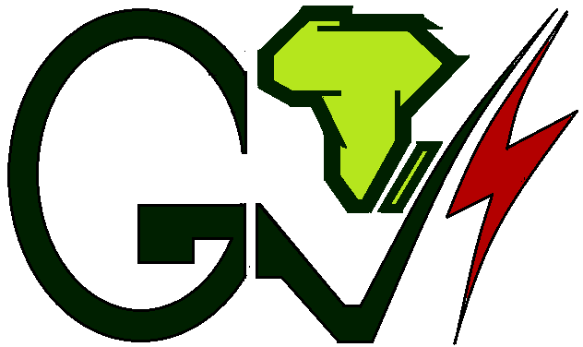

GREEN VISION COMPANY LIMITED
“Empowering Innovative Solutions”
SECURITY SYSTEMS INSTALLATION COMPANY

