Property Details

1.0 General description of the property
The property under scrutiny comprises 1 acre piece of land which is generally flat save for some parts that are gently sloping. Mostly, the subject piece of land is covered with natural vegetation including trees, grass and bushes.

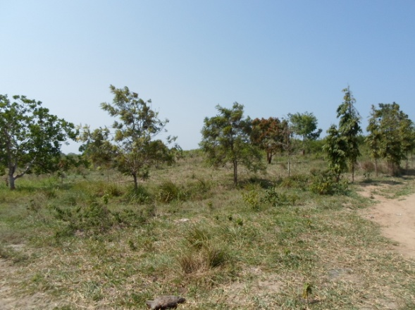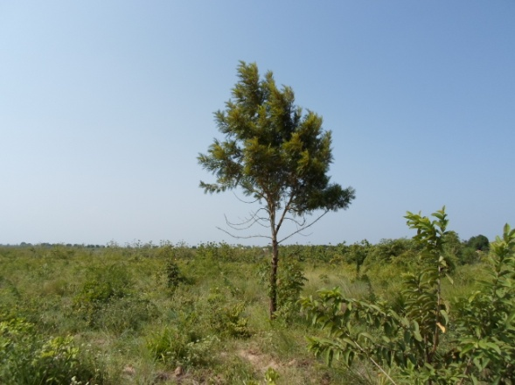

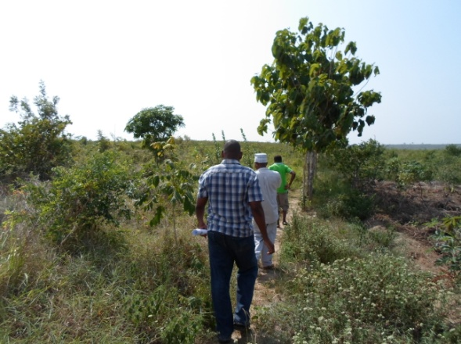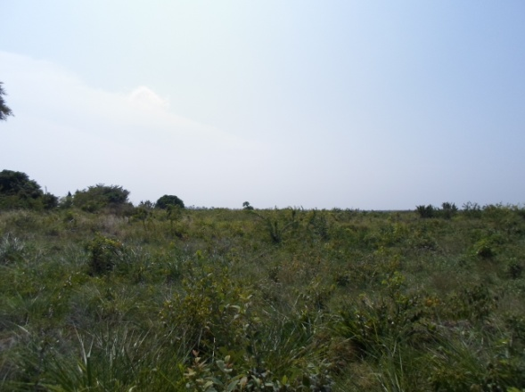
Plate 1: Various Parts of the Farm

2.0 Location and Locality
The subject property is located in Pangani Ward, Vikawe Street, Kibaha District, Coast Region. Specifically it is located near Vikawe Primary School, about 8 km from Bagamoyo road. Assuming one is driving along Stamico- Kibaha road which branches off Bagamoyo Road at Mpiji areaor Baobab Secondary School, the farm is located in the right hand side at about 0.5 km from the said road. It is located near two Orphanages namely, Almadina Orphans Centre and UMRA Orphans Centre. Save for the mentioned orphanages, the locality in which the farm is located is dominated by vacant farms and a few scattered residential and institutional properties.

3.0 Accessibility
The farm can be accessed through Stamico –Kibaha Road that branches off Bagamoyo road at Mpiji area near Baobab Secondary School. The said Stamico- Kibaha road is constructed to gravel level and it is in good condition. Assuming one is heading to the farm via the said Stamico- Kibaha Road, upon reaching Vikawe Primary School which is located in the right side of the road at about 8km from Bagamoyo road, one has to turn right and head to the farm via an earth road that passes in the left hand side of the school. The farm is then found at a distance of about 0.5km from Vikawe Primary School.

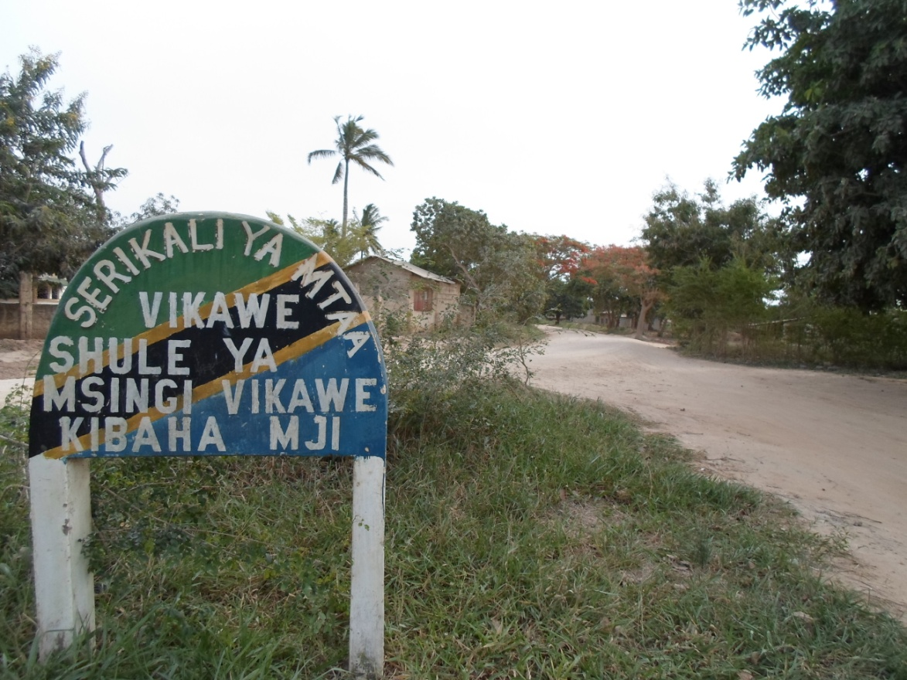
Plate 2: An earth road heading to the farm from Vikawe Primary School

4.0 Services
The area in which the farm is located is yet to be supplied with reliable water and electricity services. However preparations for provision of such services are underway. For example for the case of electricity, even poles have been installed. Such poles can noted very close to the farm under consideration.
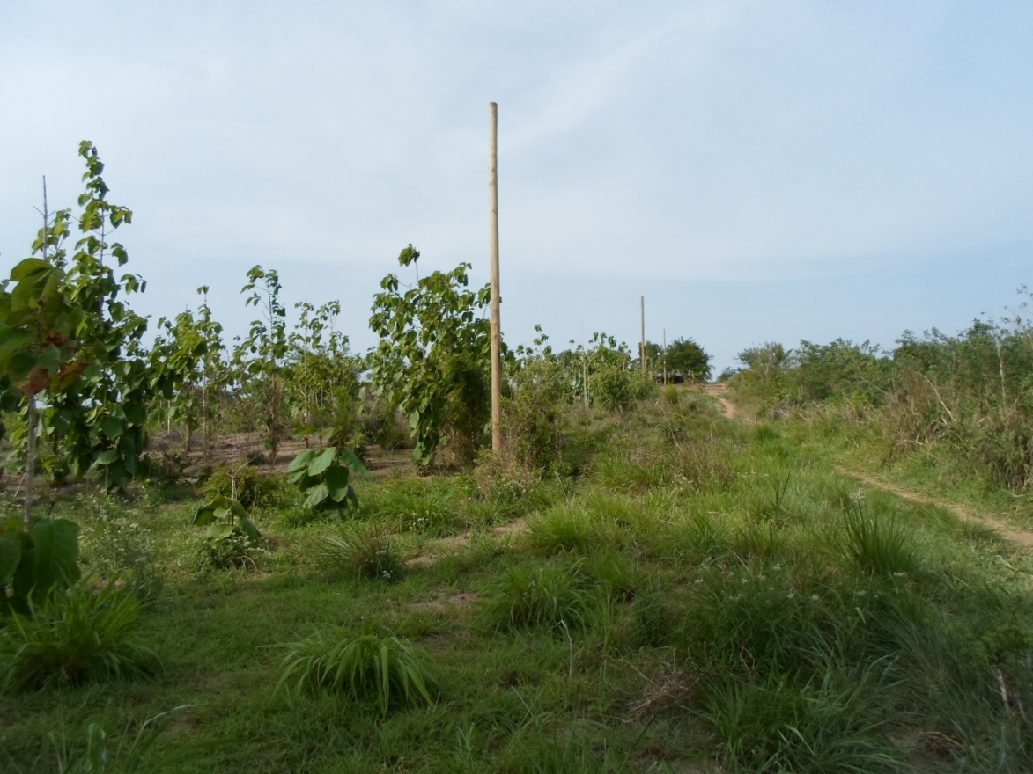
Plate 3: Electricity poles near the farm

5.0 An overview of land market in Kibaha District
The land market in Kibaha district has become very vibrant. Many people have been rushing to Kibaha to buy land. One of the factors causing increasing demand for land in the district is its being near Dar es Salaam City, a city with a population of over 4 million people. Improvement in road infrastructure particularly the completion of construction of Bagamoyo- Msata road also has contributed immensely in increasing demand for land in Coast Region in general. It is expected that the demand for land in Kibaha will keep increasing in-tandem with the increase in population in the District itself and its neighboring areas particularly Dar es Salaam city.

