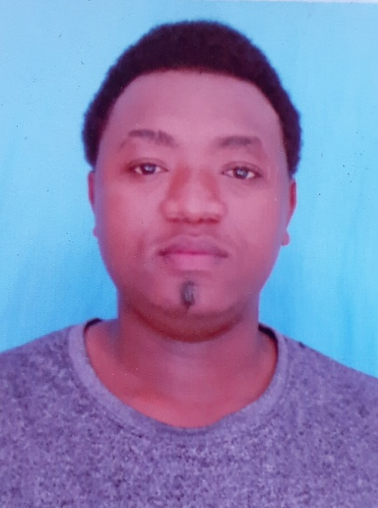

CURRICULAM VITAE

PERSONAL INFORMATION
Surname: Mlawa
Middle Name: Kisengo
Name: Chamkae
Date of Birth: 17/06/1999
Place of Birth: Dar es Salaam
Marital Status: Single
Mobile Number:+255768621981/+255629747495
Email; chamkaekisengo0@gmail.com
Language: English intermediate and Kiswahili native
Religion: Islamic
National ID No: 19990617-14118-00001-24

EDUCATION BACKGROUND
DATE | SCHOOL | AWARD
2018 | Veta Training Collage | Certificate Auto Electrical and Diagnosis Machine
2014-2017 | Juhudi Secondary School | Certificate of Secondary School
2007-2013 | AMANA Primary School | Basic Certificate

WORKING EXPERIENCE
2019: FK MOTOR LIMITED AS A TECHNITIAN
- To attending the briefing on time
- To clean the workshop area before any kind work and being smart
- Train staff on applicable health ,safety and quality procedure
- Identify and repair faults on auto electrical systems
- Manage installation and replacement of starter motors, alternators, and generators.
- Prevent potential damage or malfunction through regular inspection and preventative measures.
2020:JIEFANG MOTORS LIMITED
- Conducted routine service checks and maintenance on electrical system.
- Repaired faults in auto-electric systems including safety controls, security, lighting, and air conditioning.
- To communicate with customers and management to explain the nature of repairs and discuss possible options
- Schedule and perform routine checks and maintenance of electrical system components
- To assemble(installation ) for incomplete trucks from china until they enter the road

2021 :PALM BEACH CASINO AS A BARMAN
- To attend the briefing on time
- To ensured a clean working environment for customers as well as other employees
- To perform all end of day duties including tallying up and verifying all cash and credit transactions
- To Maintain large knowledge of drinks selection
- To mixed and served drinks to customers
- To maximize daily and weekly sales by ordering bar products and keeping a well-stocking inventory
- To gained regular customers by serving beer ,wine and other beverages in a prompt and friendly way
- To attend on other trained including in barista and mixologist
- To opened and closed the bar in a towely and responsible manner
SKILLS
- Physical ability and contribute
- Time management
- Willingness to learn
- Record keeping ability
- Team leadership
- Adaptable sand flexible
- Hand and power tools
- Loading and unloading proficiency
INTEREST
- Learning new skills
- Reading book
- Learning new cultures and traditions
HOBBIE
- Reading books
- Learning new cultures and tradition
- Learning new skills

REFERENCE
- KISENGO ALLY MLAWA
BUSINESSMAN
PHONE: +255 655 307 305
DAR ES SALAAM

- CATHARINE ALLEN SELEMANI
CHEF
PHONE: +255 753 765 900
DAR ES SALAAM
Declaration that to the best of my knowledge and beliefs this CV correctly describes myself, my qualification ,I understand that any willful misstatement describes herein may lead to my disqualification or dismissal , if engaged.



