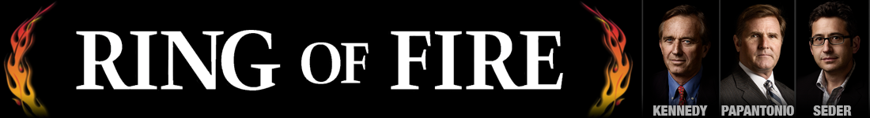
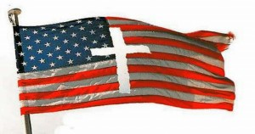
Poll: Most Republicans Want to Make Christianity the National Religion
— February 25, 2015
Results from a Public Policy Polling survey show that, unsurprisingly, most Republican participants support making Christianity the national religion, Talking Points Memo reported.
Of the respondents, 57 percent said they would support establishing the national religion, never mind that America was founded on the basis of religious freedom. They also seemed to have forgotten that the Constitution explicitly prohibits Congress from establishing a national religion.
It’s convenient that Republicans are so willing to ignore the Bill of Rights when it conflicts with any aspect of Christianity, but if you even for one minute mention any form of gun control, then you’re trying to destroy the Constitution and ruin America.
The poll also found that Wisconsin Gov. Scott Walker is the favorite for the Republican nominee for next year’s presidential race. According to the PPP:
“Scott Walker is at 25% to 18% for Ben Carson, 17% for Jeb Bush, and 10% for Mike Huckabee. Rounding out the field of contenders are Chris Christie and Ted Cruz at 5%, Rand Paul at 4%, and Rick Perry and Marco Rubio at 3%.”
The poll pointed out that Carson, who has never been elected to any government position at all, has managed to steal some of the thunder from the presumptive favorites Ted Cruz and Rand Paul.
While people have long assumed that Bush would be handed the nomination, but this poll shows otherwise. “[The] problem for Bush though is that there are two times more GOP primary voters who identify as ‘very conservative’ that there are ones who identify as moderates,” and those “very conservative” voters are unlikely to vote for Bush in the primaries.
“There is no doubt – Scott Walker is the candidate with all the momentum in the Republican race for President right now,” said PPP President Dean Debnam. “The big question is whether he will be able to sustain it in a way that most of the fleeting Republican frontrunners in 2012 couldn’t.”
Read the PPP’s full poll results here.

Follow Us

Search Our Site

