Walk of Shame: Celebs glam it up on red carpet before Whitney’s body is removed from hotel
Sunday, February 12, 2012

Self-centered celebrities such as Ciara, Diana Ross, Kelly Rowland, Kim Kardashian, and others, cheesed for the cameras on the red carpet at Clive Davis’ Pre-Grammy party at the Beverly Hills Hilton, while the body of pop icon Whitney Houston’s was in rigor mortis in her room at the same hotel.
These celebs wait all year to strut their stuff at Davis’ annual party-of=the-year, so they are not going to let something like the death of a legend stop them from being seen on the red carpet. As you look at the pics after the break, keep in mind that these celebrities were fully aware that Houston’s body had not been removed from her room yet.

What’s funnier than partying with your narcissistic friends while Whitney’s dead body is upstairs, right Kelly Rowland?

Everyone knows Kim Kardashian has no shame.
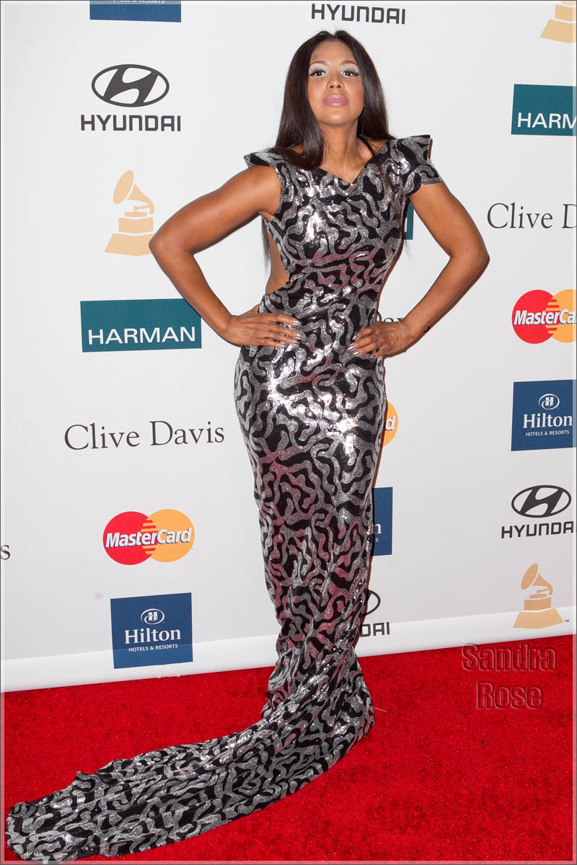
At least Toni Braxton didn’t smile for the cameras.
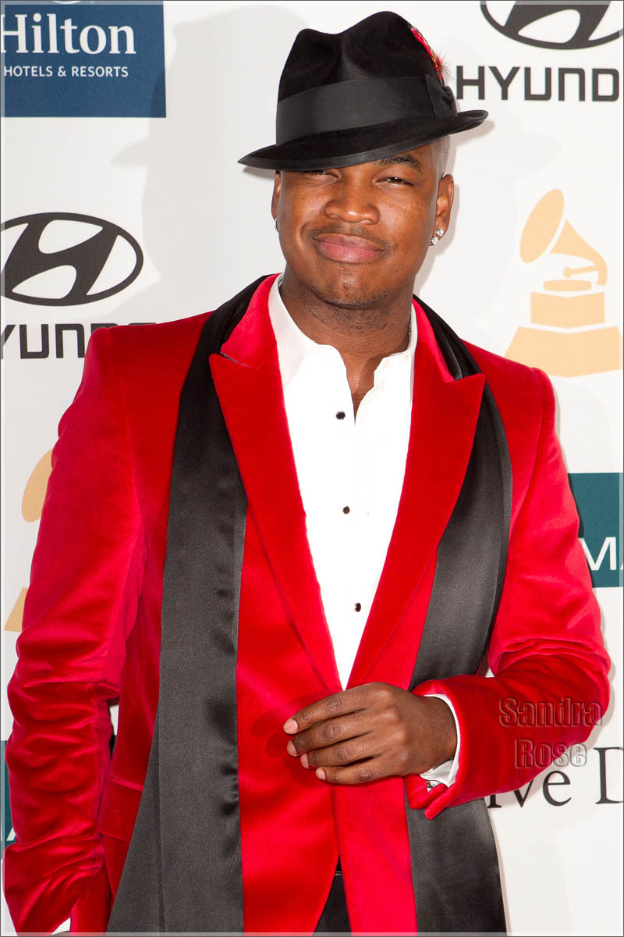
Ne-Yo couldn’t help himself. He waited all year for this party.
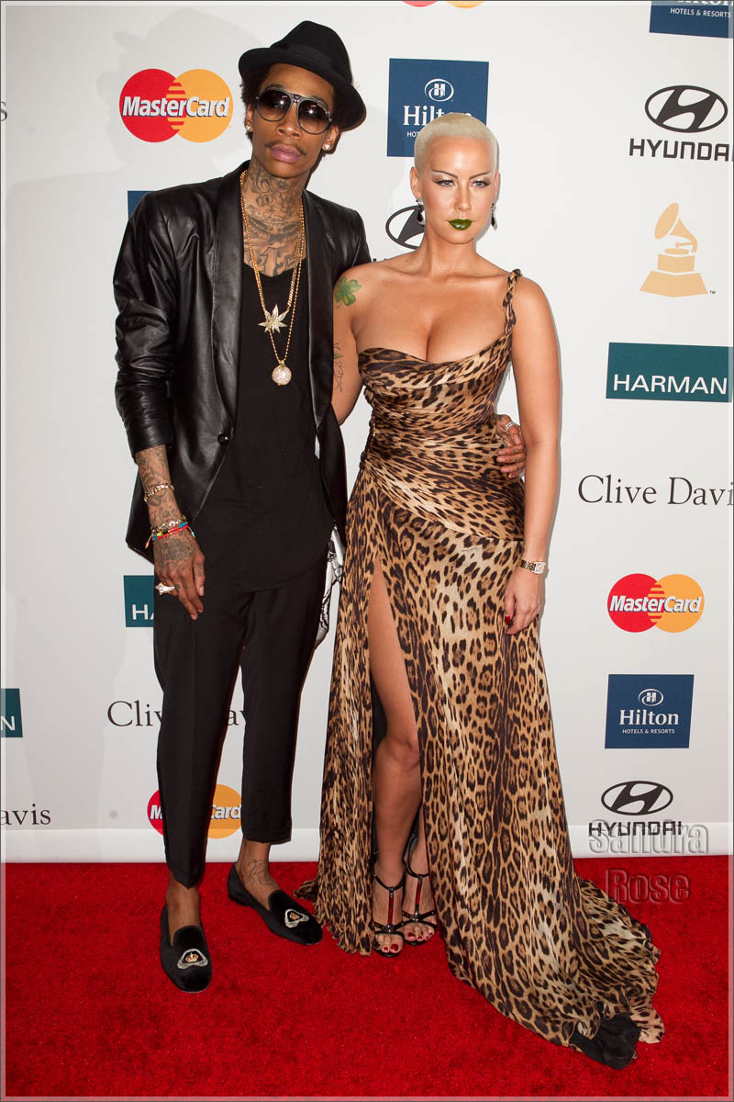
You can tell that Wiz Khalifa and Amber Rose put a lot of thought into their outfits.

