How My Dad Pablo Escobar Escaped His Own Prison
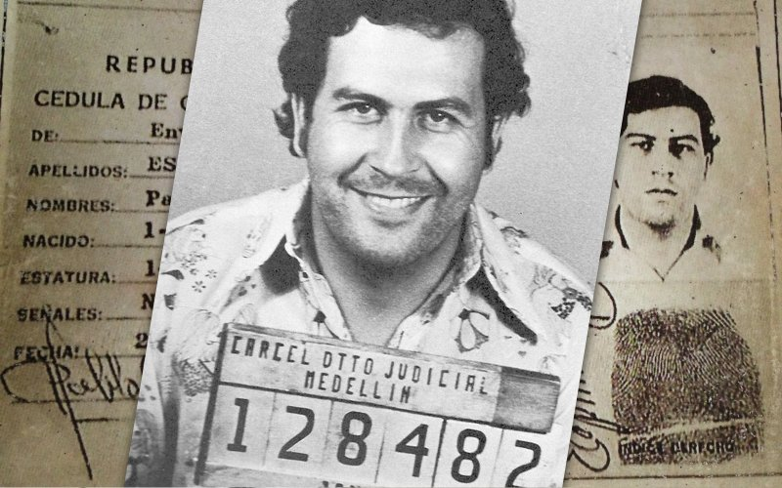

Photo Illustration by The Daily Beast
In an excerpt from his new book, Pablo Escobar’s son describes how his father cheated death by breaking out of the prison he built himself.

Juan Pablo Escobar

09.03.16 7:15 AM ET
My father didn’t carry a weapon in La Catedral because there was always a guard by his side, ready to pass him a submachine gun or a cell phone. This relaxed atmosphere suddenly evaporated, however, when the media reported that the Cali Cartel was planning to bomb the prison from an airplane.
I went up to the prison a few days later. It seemed deserted. There was nobody in the main hall, just a couple of frightened-looking guards. Where is everybody? I wondered as a guard signaled me to follow him down a dirt path toward the soccer field. From there, he pointed at the woods, where a few wooden cabins were hidden amid the vegetation.
I realized then that my father and all of his men had moved to shelters they’d built just inside the prison’s perimeter fence. I couldn’t find my father’s cabin until he emerged from a thicket and showed me the way. When I asked him what was going on, he told me he’d decided to evacuate the main building because that was the area most likely to be bombed.
“Everyone’s been instructed that if anyone flies over, we shoot. This airspace is off limits. I’m going to see if I can put in some antiaircraft artillery. I chose to put my cabin in this cleft in the mountain because it can’t be seen from above or from within the woods. Not even you could find me, so I don’t have to worry. But it’s twice as cold because there’s a little spring of ice-cold water that runs under it and the sun never reaches it.” My father had selected the worst area for his cabin.
“So you’re going to live out your sentence here? In this awful cold?” I asked.
“It’s just temporary. I told your mother to have the architect draw up some anti-bombing designs, which should be here tomorrow. Do me a favor and don’t go back to that building; it’s too dangerous.”
When we received them, the designs were futuristic, and I liked them. Each room was egg-shaped and would be protected with a huge quantity of steel and concrete and then covered with earth so it couldn’t be seen from the air or detected by satellite. But my father didn’t accept the architect’s plan, believing that wooden cabins would be discreet enough—not to mention cheaper. A few days later, he moved to a small cabin that was better located and not so cold, but just as hard to find. Though La Catedral was never bombed, my father and his men never returned to the prison’s main building.
Some time later, a number of media outlets published unconfirmed reports suggesting that Kiko Moncada and Fernando Galeano had been murdered inside La Catedral. In the ensuing panic, my father suddenly forbade anyone, including his family, to come to the prison. Something was clearly going on up there, so I called to find out why we couldn’t visit. He didn’t give me any reason, only reassured me that things would go back to normal very soon. My father and his men didn’t take kindly to being asked a lot of questions, so I decided not to push them. But my questions began to find answers when the media reported that the La Catedral prisoners had refused entry to a team of CTI investigators sent by the attorney general’s office to inspect the prison and confirm or rebut the rumors about the disappearance of my father’s two business partners.
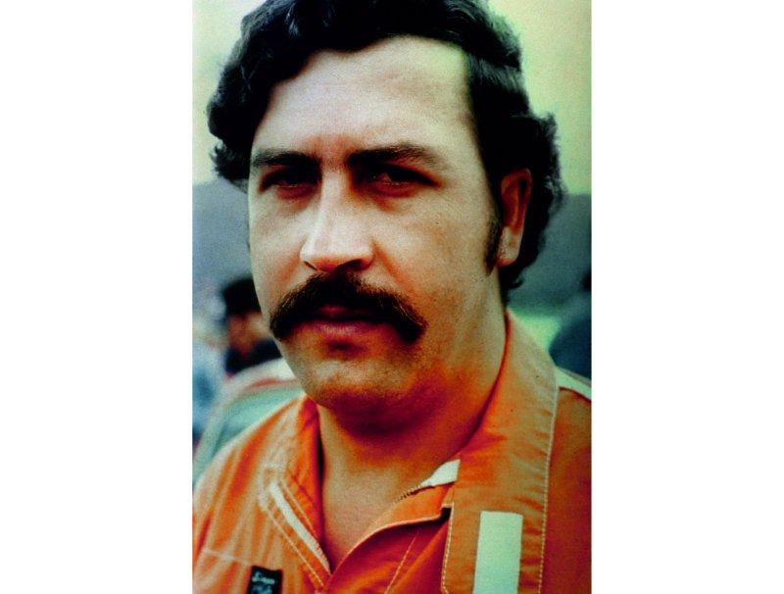
Pablo Escobar
Only a few days earlier, before we’d heard the news that Moncada might be dead, my parents and I had been walking through the prison when a mischievous smile formed on my father’s face, the same one he always wore when he’d pulled off a job. Eventually he couldn’t hold back any longer and said, “I’m really happy, darling. I’ve got really excellent news. I’ve just paid Kiko all of the debt I owed him after he’s helped out so much with our cause. I earned a little money with him in Mexico, and the good news is that my part of the take was thirty-two million dollars. Minus the twenty-four I owed him, that leaves me eight million in the black.” Remembering how close my father and Moncada had been, it all sounded quite strange. I couldn’t believe that the journalists’ claims might be true.
A couple of days later, my father authorized me to visit once more. I arrived at the tavern late and found a lot of people in line to go up to La Catedral. Though they gave me priority, I had to wait a pretty long time, and Shooter and Tití came up to say hello.
“What’s up, Juancho, man, how you doing? All good?” Shooter inquired.
“All good, Grasshopper, my man, how are you and the old lady?” I answered.
“All good. And what did you think of the coup?” he asked nervously.
Just then they called me to the truck, and I only managed to gesture to him that I had no idea what he was referring to. Shooter’s question echoed in my mind, and it didn’t take me long to connect the “coup” with the rumors about Kiko Moncada and Fernando Galeano. I took it as a sign that the order to kill them might actually have come from my father.
Still pondering Shooter’s question, I was shocked by the possibility that my father could be such a terrible friend. He had always taught me the importance of loyalty, and many of his problems had stemmed from his eagerness to help friends. I can’t say much about Galeano because I never met him. I first heard his name and learned that he was part of the cartel only when the gossip about his death began.

Get The Beast In Your Inbox!
Daily DigestStart and finish your day with the top stories from The Daily Beast.
Cheat SheetA speedy, smart summary of all the news you need to know (and nothing you don't).
By clicking "Subscribe," you agree to have read the Terms of Use and Privacy Policy

As soon as I had the chance to speak with my father, I told him I was troubled. “Papá, what is going on? I’m worried. On the news and around town, people are saying that Kiko is dead. Is that true? You and he were such good friends. So what happened to him?”
“Son, I’ll tell you so they don’t feed you a pack of lies,” he began. “What I heard is that the Cali Cartel picked up Kiko and Galeano and released them in exchange for their promise that they wouldn’t help me finance the war against Cali, that they’d cut off all economic support and pass on information about me. I didn’t believe it was true at first—as you know, Kiko was a good friend of mine. But then I heard recordings of one of the Cali narcos telling Kiko off because he was still giving me money.”
“But what did Kiko actually do to you?” I asked, sensing that my father seemed willing to discuss it.
“Well, I had him come up so I could show him the intelligence we’d been gathering on the Cali Cartel and tell him about a couple of operations that we’d set up to take down Gilberto Rodríguez and Pacho Herrera, but suddenly it all went awry and the police and the Cali guys arrived and engaged my men in a gunfight. The first time it happened I figured it could be a coincidence, but the second and third times I looked into it and was able to identify the person who was feeding them the information.
“I’m sure he did it because he was scared. Kiko was never one for violence. But everybody knows what happens when you do me like that. He was a dear friend, and I did everything I could to avoid that outcome, but instead of coming to tell me what was going on, he allied himself with my enemies. The same thing happened with Galeano: I sent him a message asking for money, and he told me he was broke and would no longer be able to contribute. A few days later Tití showed up and said he found one of Galeano’s caches with something like twenty-three million dollars in it. Don’t ask me for any more details, that’s all I’m going to say. Kiko and Galeano double-crossed me with the Cali guys.”
I was silent, and my father left for a meeting. When he returned, he warned me, “Careful with Fidel Castaño if you see him. I found out he’s another traitor who’s working with Cali and going around saying I’m killing my friends so I can take their money. So watch out. If you see him, watch out for him and Carlitos, his brother.”
I later discovered that my father tried to force the same fate on the Castaño brothers as he had on Moncada and Galeano. He invited them to La Catedral together, but Fidel was suspicious and had Carlos stay down below. They never spoke again, and the Castaños would end up aligning themselves with Los Pepes, the group that would eventually bring my father down.
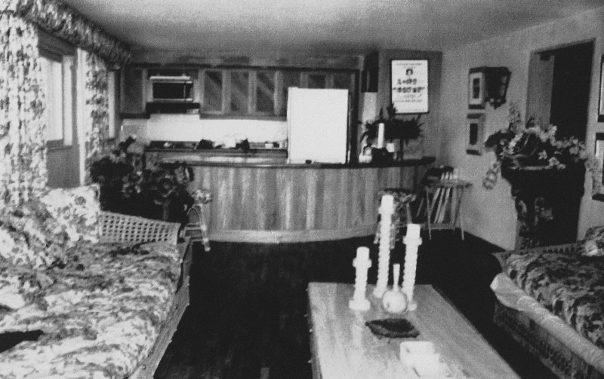The living room and kitchen of the prison occupied by Pablo Escobar before his escape.

On the afternoon of Tuesday, July 21, 1992, my bodyguards, a few friends, my cousin Nicolás—my uncle Roberto’s son—and I played soccer in a place known as the 20, in the upper section of Envigado. After the game, Nicolás invited me and a friend to a barbecue at his penthouse apartment in a building four blocks from the Oviedo shopping center in Medellín. At around six, Nicolás received a call on his cell phone from Roberto, who sounded upset: “Stay posted. Something strange is going on outside La Catedral.”
Then my father came on the line. “Grégory, there are more soldiers than usual and military trucks. There are helicopters circling overhead, too. Something may go down, but we don’t know what.”
“What should I do in the meantime, Papá?”
“Call Giovanni and tell him to go to you in case I need to talk to him.”
The unexpected phone call left us extremely worried, especially Nicolás, who had the feeling his father had been saying good-bye. My father had seemed fairly relaxed, but that didn’t mean too much because he amazingly was always composed, even in the worst moments.
An hour later, Roberto called again. I answered.
“Juan Pablo, go get my children and let me speak to them. I think they’ve come to kill us, and I want to say good-bye.”
“Uncle, let me talk to my father. What should I do? Should I call the authorities?” I said.
My father got on and told me to let him talk to Giovanni, who had just arrived at Nicolás’s apartment.
“Giovanni,” he said, “send people to Olaya and Rionegro to check if there are any American planes at the airports there. Have everything ready to go. If there’s a suspicious plane, wait for my orders to destroy it.”
The first shadows of night began to fall over Medellín, and we still had no idea what was happening. But soon Roberto called again, and after that we were in constant contact with him. Through short conversations with Nicolás, Roberto reported that the army had arrived at the prison gates, but the prison guards—who in actuality were my father’s men—had refused them entry and aimed their weapons at them, as they were trespassing on the territory of the National Directorate of Prisons and violating the official government accords stating that the military would be allowed only outside the perimeter.
Soon after, he told us the situation was becoming complicated, and they were afraid there might be an armed conflict with the soldiers. My father had commanded the men to ready all their weapons and barricade themselves in strategic positions throughout the prison.
By that time, Giovanni had confirmed that no foreign airplanes had landed that day in nearby airports. He also assured my father that several of his men were on the alert and reachable by cell phone.
In an effort to resolve the situation, I decided to play one of our cards. I asked Giovanni to accompany me to the home of Juan Gómez Martínez, the governor of Antioquia, who might have information on what was happening at La Catedral. On the way there, Giovanni revealed something I hadn’t known at the time: my father had ordered his men to kidnap Gómez Martínez back when he was the editor of El Colombiano, but he had barricaded himself in his house with a .38 revolver and managed to fend off the twenty men who’d been sent after him.
This story didn’t exactly fill me with optimism, but Giovanni thought we might be able to get an audience with the governor if he presented a press card from a Medellín radio station. This strategy worked, and when we arrived at the governor’s residence, the police officers posted out front let us through immediately.
After we rang the bell several times, Gómez Martínez opened the door. He looked half asleep in a robe and with his hair disheveled. Giovanni spoke first: “Governor, I’m a journalist, and we’ve come here to see you because there’s something going on at La Catedral. There is unusual activity happening, so I’m here with Juan Pablo, Pablo Escobar’s son.”
“Governor, they’re very worried up there. The government promised it wouldn’t move the prisoners,” I said.
Gómez Martínez couldn’t hide his surprise and some displeasure at my presence in his home, but he told us to wait while he made inquiries. He closed and bolted the door. Ten minutes later, he appeared again. He’d called the Casa de Nariño in Bogotá, the Fourth Brigade headquarters in Medellín, and several generals, and no one had given him any information. He did note that one general had shared that the operation’s objective was to take my father into military custody.
When we got back to Nicolás’s apartment, we were updated with several pieces of alarming information. The army had the prison surrounded, and the vice minister of justice, Eduardo Mendoza, and the director of prisons, Colonel Hernando Navas Rubio, had come from Bogotá with the news that the government was transferring my father to another prison. My father had allowed the two men to enter the prison, and he argued with the vice minister and absolutely refused to comply. The situation escalated, and Mendoza and Navas were tied up as Little Angel, Otto, and Crud trained weapons on them. In other words, the officials were being held hostage inside La Catedral, which the army was threatening to occupy by force. My father claimed that Mendoza and Navas were a sort of life insurance policy.
At that moment, Dora, my uncle Roberto’s wife, arrived at the apartment and managed to reach Roberto by cell phone. They spoke for several minutes, wept bitterly, and said good-bye.
One of the people who had been present at La Catedral that night later told me that when my father recognized how nervous the guards and prisoners were, he assured them, “Boys, don’t get nervous yet. When you see me tie my sneakers, then you can go ahead and worry.”
Later, he did just that, placing his left foot up on a wall and tying his shoe, then doing the same with the right. It became clear to the men who were with him that night that my father was planning to escape from La Catedral.
My father was still on the line. “Look, Grégory, do you remember Álvaro’s house?” he said, referring to the property by the name of its caretaker.
“Of course, Papá.”
“Are you sure you’ve never taken anyone there?”
“I have taken a few people there, Papá, but I’m sure it’ll be a good hideout for you.”
“Go ahead and get it ready,” he instructed me.

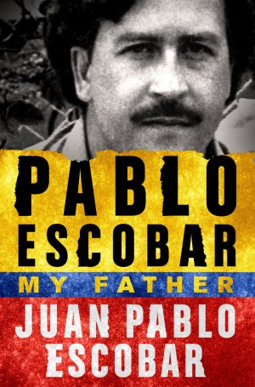

Courtesy St. Martin's Press
‘Pablo Escobar: My Father’ by Juan Pablo Escobar (Author), Andrea Rosenberg (Translator) 368 p. Thomas Dunne Books. $20.53
A few minutes after we hung up, from the living room of Nicolás’s penthouse, there in the hills above Medellín we saw La Catedral suddenly go dark. On the instructions of my father, who had just reached the perimeter fence with the other fugitives, a guard shut off the lighting system for the entire prison.
Once everything was sunk into darkness, the men opened a hole in a brick wall and crawled through. My father had created this escape route during the construction phase; the section of the wall had been mortared with a very weak mix of concrete, so all it took was two kicks to break it open.
When we didn’t hear anything from the fugitives for a while, Nicolás and I decided to wait at Álvaro’s house.
But my father never arrived. He was already swimming in the pool at the farm known as Memo Trino in El Salado, where he and the nine men who’d fled with him, including my uncle Roberto, had taken refuge. From there they could hear the explosions and the commotion of the soldiers who’d stormed the prison to capture my father.
It would take them twelve hours to conclude that he’d escaped.
From Pablo Escobar: My Father by Juan Pablo Escobar. Original text copyright © 2014 by Juan Sebastián Marroquín Santos and Editorial Planeta Colombiana, S.A. English translation copyright © 2016 by Andrea Rosenberg. Reprinted by permission of St. Martin’s Press, LLC.
Son of the leader of the Medellín cartel, Pablo Escobar, Juan Pablo Escobar is an architect, lecturer, drug policy reform advocate, and writer. He was a subject of the award-winning documentary Sins of My Father and lives in Argentina.

