Passing on the great Highway, it would seem that the Kantō earthquake of 11 March never happened: the street is perfect.
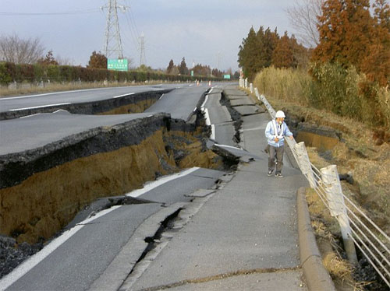
Here's the picture of the Road shortly after the earthquake.
Destroyed by the earthquake, now it is again passable. Work has begun on 17 March and six days after….


