FISH SEED PRODUCTION BUSINESS PLAN

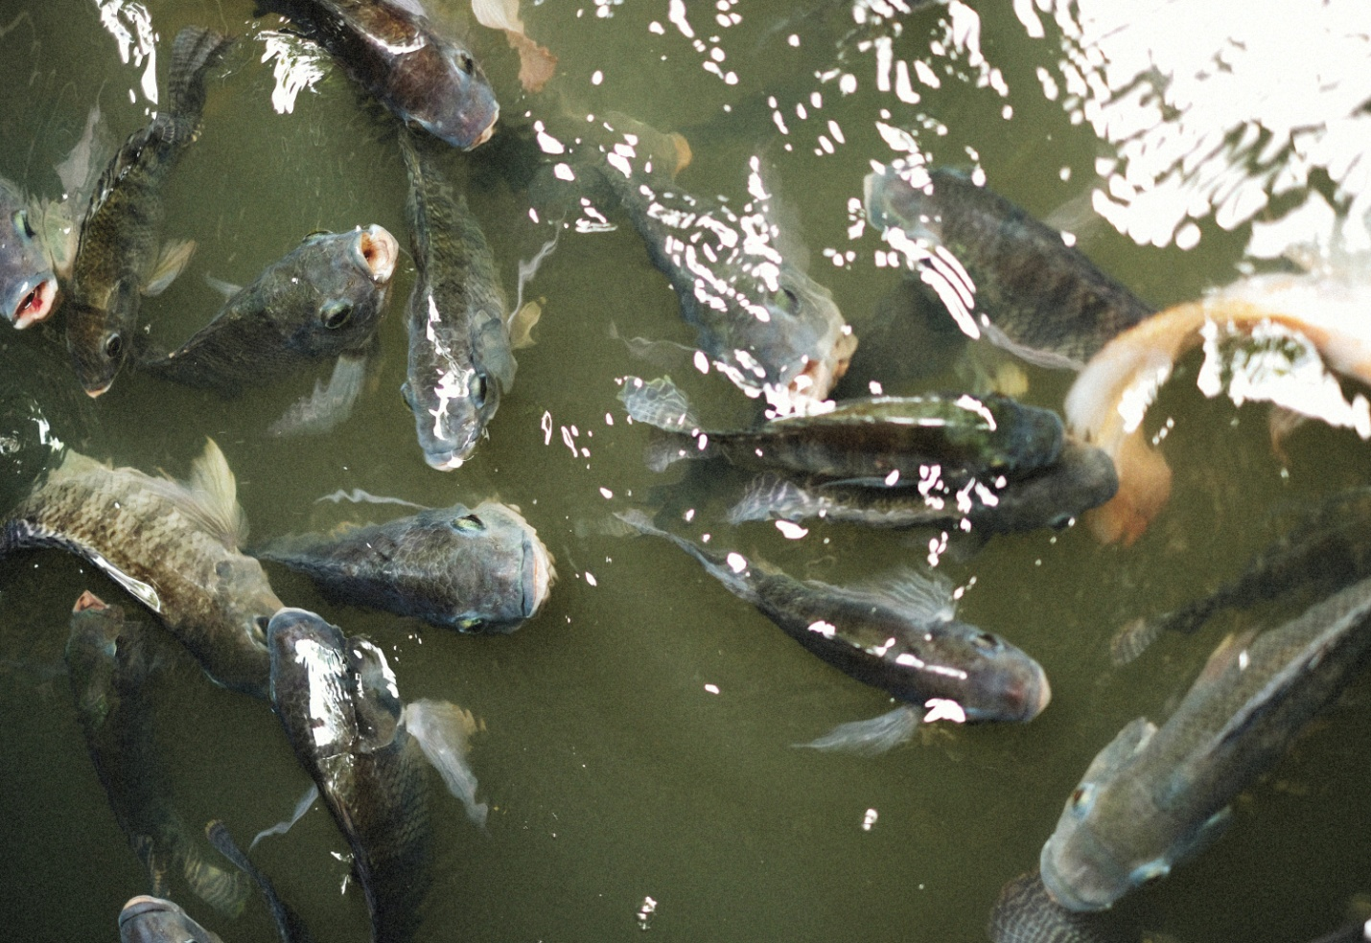

Executive Summary

This business plan outlines the establishment of a fish seed production project, including the construction of a hatchery facility. The project is located in Tanga and aims to produce high-quality fish seeds to meet the growing demand in the region. The primary objectives are to ensure cost-effective operations, sustainable practices, and profitable returns.

Business Objectives

- Establish a hatchery facility with the capacity to produce more than 100,000 fries each month.
- Ensure high survival rates and quality of fish seeds through effective management and advanced techniques.
- Achieve profitability within the first year of operations.

Market Analysis

There is a growing demand for fish seeds in the region, driven by increasing fish farming activities and a preference for reliable and high-quality fry suppliers. This project aims to meet this demand by providing high-quality fish seeds to local fish farmers.

Marketing Strategies

- Hiring 2 marketing officers who will be paid by commission. For example, if the fish seed sells for 200 Tsh, the marketing officer will sell for 250 Tsh, and the additional 50 Tsh will be their wages.
- Advertising through radio, TV, and social media.
- Allowing and inviting people/organizations to learn about fish farming.
- Initiating seminars to create awareness and generate new customers.

Hatchery Construction and Operational Costs

Pond Construction

- Pond Size: 100m²
- Construction Cost per Pond: 100m² x 17,000 Tsh/m² = 1,700,000 Tsh
- Total Cost for Four Ponds: 4 x 1,700,000 = 6,800,000 Tsh
- Hatchery Building: 1,000,000 Tsh

MATERIAL AND EQUIPMENT

Item | Quantity | Unit Cost (Tsh) | Total Cost (Tsh)
Happanet | 1m | 4,000 | 100,000
Tanks | 4 units | (not specified) | (not specified)
Aerators | 2 units | 200,000 | 400,000
Incubator Jars | 3 units | 20,000 | 60,000
Gas and filling | 1 unit |  | 200,000
Packaging Roller | 1 unit | 200,000 | 200,000
Hormone (17 Alpha Methyltestosterone) | 1 unit | 150,000 | 150,000
Ethanol | 1 unit | 50,000 | 50,000
Weighing Balance | 1 unit | 50,000 | 50,000
Total |  |  | 1,010,000

Other Costs

- Electricity: To be evaluated based on local rates
- Water Supply: To be evaluated based on local rates
- Salary: To be determined based on staffing requirements
- Maintenance: 200,000 Tsh
- Emergency Fund: 1,000,000 Tsh

Feed for Brooders and Fry

- Feed for Brooders: 495 kg x 3,000 Tsh/kg = 1,485,000 Tsh
- Feed for Fry: 50 kg x 6,200 Tsh/kg = 310,000 Tsh

Total Construction and Initial Operating Costs
Expense | Cost (Tsh)
Pond Construction | 6,800,000
Hatchery Building | 1,000,000
Materials and Equipment | 1,010,000
Maintenance and Emergency Fund | 1,200,000
Feed | 1,795,000
Total | 11,805,000

Hatchery Output
- Monthly Fry Production: ** 100,000 fries
- Selling Price per Fry: 200 Tsh
- Monthly Revenue from Fries: 100,000 fries x 200 Tsh = 20,000,000 Tsh
- Annual Revenue from Fries: 20,000,000 Tsh x 12 months = 240,000,000 Tsh

Total Annual Revenue
- Total Revenue: 240,000,000 Tsh

Profitability Analysis
- Total Annual Revenue: 240,000,000 Tsh
- Total Initial Investment: 11,805,000 Tsh
- Net Profit: 240,000,000 Tsh - 11,805,000 Tsh = 228,195,000 Tsh

Conclusion
The fish seed production project is a viable and profitable venture. With careful implementation of the outlined construction and operational plans, the project is expected to generate substantial revenue and achieve profitability within the first year. Proper management and adherence to sustainable practices will ensure long-term success and growth in the fish seed production industry.


