ERN tox binder

Mode of Action

Mycotoxins are always seen to be one of the most important problems for animal feeding stuff. They are natural contaminators produced by certain forms of moulds which develop in crop before harvest or during storage. They give very big damages to the animals and in this case ERN Tox binder is an efficial mycotoxin binder with its active ingredients. Mode of action of this product cannot be destroyed by multi-toxins in the product, it can suppress different kind of mycotoxins.

Mycotoxins cause economic losses, in order to prevent this, needed quantity of ERN Tox binder should be used in the feeding stuff.

Mycotoxins have negative effects on immune system, growth performance, feed consumption, fertility problems.

Advantages of ERN Tox binder

• It absorbs Aflatoxin,Ochratoxin,Zearalonone,Vimotoxin,T-2 toxin, Fumonis that can form in feed raw materials.
• It decreases the deaths and illness which are caused by mycotoxins
• It enhances the performance of animal.

EuroTOX Composition

MOS (mananOligosaccharides) ,HSCAS (Hydrated sodium calcium aluminosilicate), Protectors (calcium propionate- copper sulphate-sorbic acid-citric acid)

Dosages

In toxin risky cases 1,0-2,0 kg/ton
In toxin contaminated cases 1,0-3,0 kg/ton

Advantages

• It absorbs humidity in the feed.
• It prevents caking.
• It increases fluidity of the feed.
• It binds Mycotoxins with electro-chemical method.
• It absorbs Mycotoxins which do not show Polarity (which do not have poles)
• It prevents reproduction of molds.
• It renews technical performance.
• It enhances the quality of the feed.
• It decreases mortality.

Growth parameters of Molds and Fungi

Molds and Fungi are microorganisms resistant to adverse conditions. Contamination per cent of feed materials with pathogenic microorganisms is important. Although Mycotoxins are a big question in animal feeding all over the world, they show climatic differences. While Fusario molds are seen mostly in warm climates, Zaerelenone T-2 aflatoxin and ochratoxin Mycotoxin types are mostly seen in hot climates. But all Mycotoxin types exist together in order not to spoil the contamination of the feed. As a result, ERN Tox Binder are added into the feed or feed raw material to suppress these Mycotoxins and remove pathogens from the environment

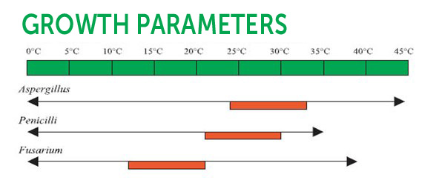

Heat Tolerance of Mycotoxins

60-1300C Heat Treatment to be applied for protecting animals from negative conditions that Mycotoxins may create does not provide a safe protection. Aflotoxins trichotocens are resistant to this temperature.

Some organs of poultry to which Mycotoxins give harm:

Mycotoxins give damages to some organs of the animals. They effect the functions of the organs negatively. These mycotoxins cause chronic diseases and performance losses

Aflotoxins: Liver Deformation, Lower Performance

Ochratoxins: Upper Respiratory Tract Infection that Pathogenes create, Deterioration in immune system, and Lower performance

DON : or vomitoxin when feed consumption, problems in immune system, and lower performance.

T-2 Toxin : problems in immune system, beak lesions, mucosal deformation.

Effects of Mycotoxins on Animal



