Drip Irrigation Kits

PHOTO | DESCRIPTION | QUANTITY
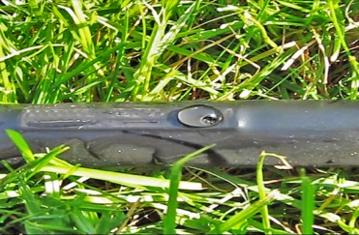 | Plastic pipe(Drip tape with flat emitters)  D16mm,T0.18mm, S40cm, 3.0L/H | 4000m
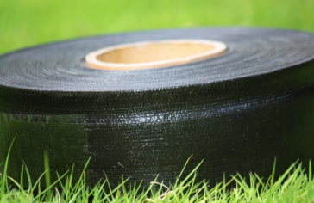 | PE Layflat Hose  3'' | 100m
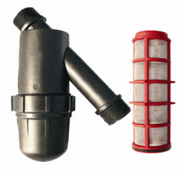 | Screen Filter 1 1/2'';120mesh;Filtering capacity:16 cube meters/hour | 2pc
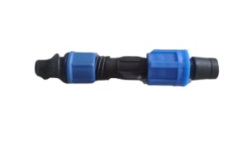 | FB0317  offtake for pipe Dn17 | 200pcs
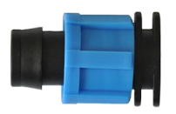 | TP0117  end plud for tape，Dn17 | 200pcs

