1.Enter in the Setting menu, input the password:1512,then the XCAM Setup menu will be displayed,
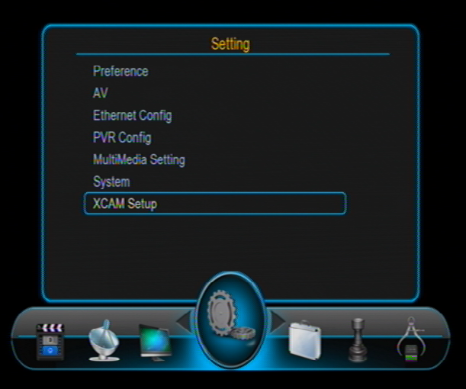

2.Enter in the XCAM Setup menu:
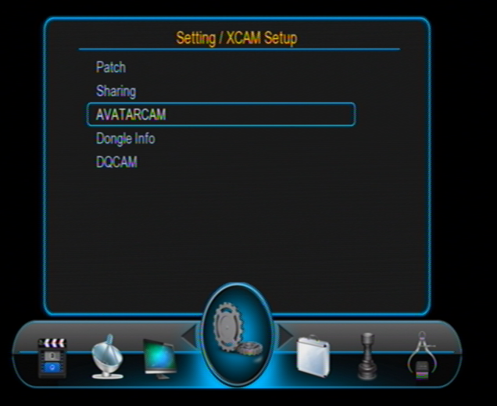

3. And enter in the DQCAM menu, the DQCAM ON/OFF set to On.
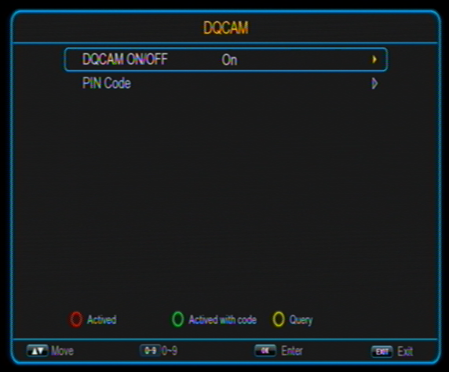

4. Press Active button.

