A 79-year-old retired officer of the CIA, Bill Oxley, has made a series of stunning confessions since he was admitted to the Mercy Hospital in Maine on Monday and told he has weeks to live. He claims he committed 17 assassinations for the American government between 1974 and 1985, including the music icon Bob Marley.
Mr. Oxley, who worked for the CIA for 29 years as an operative with top-level security clearances, claims he was often used as a hitman by the organization, to assassinate individuals who could represent a threat to the goals of the agency.
Trained as a sniper and marksman, Mr. Oxley also has significant experience with more unconventional methods of inflicting harm upon others, like poisons, explosives, induced heart attacks and cancer.
The 79-year-old operative claims he committed the assassinations between March 1974 and August 1985, at a time when he says the CIA “was a law unto itself.” He says he was part of an operative cell of three members which carried out political assassinations across the country and occasionally in foreign countries.
Most of their victims were political activists, journalists, and union leaders, but he also confesses to assassinating a few scientists, medical researchers, artists and musicians whose ideas and influence “represented a threat to the interests of the United States.”
He claims he had no problem with going through with the assassination of Bob Marley, because “I was a patriot, I believed in the CIA, and I didn’t question the motivation of the agency. I’ve always understood that sometimes sacrifices have to be made for the greater good.”
But Mr. Oxley confesses that Bob Marley remains unique among his victims, as he was the only victim he “felt anything for.”
“The others were assholes. Bob Marley was Bob Marley. I was no closer to being a long-haired hippy back then than I am now, but I must admit Bob’s music did move me. It held some power over me.”
He claims to have “mixed feelings” about Bob Marley’s death. On the one hand, Marley was “a good man, a beautiful soul” with “profound artistic gifts” who did not deserve to have his life cut short. But according to Mr. Oxley, Bob Marley was also placing the goals of the CIA in jeopardy and threatening the existence of the United States:
“He was succeeding in creating a revolution that used music as a more powerful tool than bullets and bombs. Bob Marley in 1976 was a very serious threat to the global status quo and to the hidden power brokers implementing their plan for a new world order. As far as the agency was concerned, Bob Marley was too successful, too famous, too influential… A Jamaican Rastaman who started using his funds and fame to support causes around the world that were in direct conflict with the CIA… To be honest, he signed his own death warrant.”
“It’s not like we didn’t warn him. We sent a few guys to shoot up his house in Kingston,” Mr Oxley says, referring to a shooting in the Marley residence that left the singer with an injured arm and chest. “We had a message for him. We impressed upon him the gravity of the situation he found himself in. He didn’t listen.”
“Two days later, in the mountains, I stuck him with the pin.“
How Bob Marley was murdered by the CIA
Two days after Bob Marley was shot in the left arm by one of three gunmen who ambushed the singer and some of his crew in his house in Kingston, and after a brief stint in hospital, Bob Marley travelled to the protective hills of the Blue Mountains and spent time at the highest point in Jamaica, rehearsing for an upcoming concert.
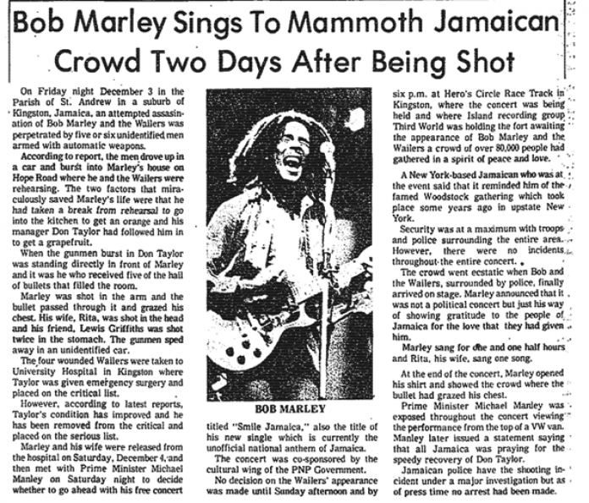
According to Mr. Oxley, he used press credentials to gain access to Bob Marley during his Blue Mountains retreat. He introduced himself as a famous photographer working for the New York Times, and gave Bob Marley a gift.
“I gave him a pair of Converse All Stars. Size 10. When he tried on the right shoe, he screamed out ‘OUUUCH.‘
“That was it. His life was over right there and then. The nail in the shoe was tainted with cancer viruses and bacteria. If it pierced his skin, which it did, it was goodnight nurse.”
“There had been a series of high-profile assassinations of counter-culture figures in the United States in the late sixties, early seventies. By the time Bob Marley’s time came around, we thought subtlety was the order of the day. No more bullets and splattered brains.”
Mr. Oxley says he kept close contact with Marley during the final years of his life, ensuring the medical advice he received in Paris, London and the United States “would hasten his demise rather than cure him.” He died from cancer in May 1981. He was just 36 years old.
The final photo of Bob Marley, days before his death.
“The last time I saw Bob before he died he had removed the dreadlocks, and his weight was dropping like a stone,” he says.
“He was very withdrawn, unbelievably small. He was shrinking in front of us. The cancer had done it’s job.”
“The day he died in Miami was definitely one of the most difficult moments in my career. I felt real bad. For a long time I wasn’t comfortable with my part in his death. But eventually I came to realize it had to be done, for America.”
Somo: Wakati mwingine hakuna kumwamini mtu.

